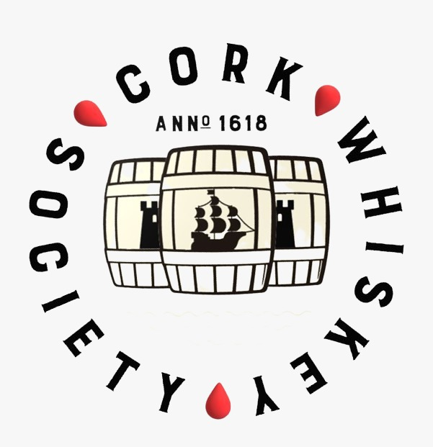

CASK OWNERSHIP

We are delighted to offer members the chance to own a 1% share of a Killowen Cask.

75% of this cask will be made available for private share ownership to current members only.

Share ownership fixes a low price for your whiskey, with only excise and packaging costs payable at bottling.

CASK SUBSCRIPTION

Cork Whiskey Society have purchased a Hungarian Tokaji white wine cask and filled it with a Killowen peated single pot still distillate. This currently doesn’t conform to any current definition under the Irish whiskey technical file.

This barrel has been laid down to its peaceful slumber in the Killowen maturation warehouse.

This cask has been filled with 227 litres of pungent new make spirit, double distilled by traditional copper pot stills of Killowen Distillery.

Cask ownership is available STRICTLY to Cork Whiskey Society members only. Membership must be maintained throughout the maturation process. If membership lapses, then you are obliged to sell your share back to Cork Whiskey Society at the original cost price.

Once the purchase of the cask share has been completed we will update your personal records on our member page showing your cask Share ownership Your ownership cannot be sold or transferred without the prior written consent of the committee of Cork Whiskey Society.
re

HOW DOES IT WORK?

Initial Cost – The initial cost will be €60.00 for a 1% Share. 1% equates to 2.27 liters (1%) of the original new-make spirit volume of 227 litres. As the whiskey matures, the Angels will of course take their share and evaporation will decrease the volume over time.

Evaporation – The Excise authorities suggest 2% per year + a further 6% as average evaporation losses.

Duty - The Office of the Revenue Commissioner currently list the rate of duty on spirits as €42.57 per liter of pure alcohol. The assessment is based on the abv strength of the whiskey – please note we will bottle at cask strength. You will be liable for your share of these costs at maturation.

Bottling & Packaging – We have estimated costs for both. We will most likely offer an option on packaging. Collectors will want packaging (e.g. cases) while drinkers will only require the bottle itself. You will be liable for your share of bottling and packaging costs.

What happens part filled bottles – For example if you end up with 2.5 bottles (see 5-year maturation below for €50 investment) we will endevour to give you the option of purchasing whiskey to complete a full bottle or we may have no choice but to buy back the excess half liter volume. The price for part volumes will be determined by the Committee of Cork Whiskey Society. The decision of the Committee will be final on all bottling matters.

When will I get my bottles - The Committee of Cork Whiskey Society will decide, based on tasting, when bottling takes place. It is most likely to be a medium-term investment of 5 years to 7 years, but of course it could take longer depending on the whiskey.

Important – Do not purchase a cask share if you cannot maintain membership of the society. We do not attribute a value or future value to the cask, if you let your membership lapse we will refund your initial purchase of €60 immediately and without reference to you.

Phone: 086 021 5524
E-mail: CorkWhiskeySociety@gmail.com

Website: CorkWhiskeySociety.ie

Contact: Ray Foley (Treasurer)

Estimated Bottling & Associated Costs
 |  | 5 Year Maturation |  | 7 Year Maturation
 |  | 1% |  | 1%
Initial Investment Cost June 2021 |  | €60.00 |  | €60.00
Initial Liters Purchased June 2021 |  | 2.27 Litres |  | 2.27 Litres
Estimated – Evaporation (2% per year + 6%) |  | 16% |  | 20%
Estimated – Litres Remaining after maturation |  | 1.90 |  | 1.80
Estimated – ABV at Maturation |  | 61.50% |  | 60.10%
Estimated – 70cl Bottles at maturation |  | 2.7 |  | 2.5
Estimated – Revenue Duty owed |  | €44 |  | €42
Estimated – Cost to Bottle 2 Bottles (€5 per bottle) |  | €12 |  | €12
Estimated – Cost to package 2 Bottles  (€15 per bottle) |  | €30.00 |  | €30.00
Total Final Estimated Cost |  | €146 |  | €144

Important Info & Terms & Conditions

- Figures quoted above are estimates, they are subject to change and are intended only for your information to allow you make an informed decision on purchasing a share or not. They cannot and will not be relied upon when it comes to the time of bottling. Your 1% share of whiskey will essentially be 1% of the remaining whiskey at the time of bottling after the angels have had their share.
- The taxes due will be calculated at that time.
- For incomplete bottles, where for example you are entitled to 2.22 full bottles, then the 0.22 of a full bottle can either be sold back to the society at a price to be agreed or if available additional whiskey can be bought to make up a 3rd complete bottle.
- Share ownership cannot be transferred, sold or gifted, to another individual unless he/she is a current member of Cork Whiskey Society and express written authorisation has been sought from, and provided by, the Committee of Cork Whiskey Society.
- Share ownership remains active "only" for current members of Cork Whiskey Society
- Any member that expressly decides to leave his/her membership lapse is obliged to sell his/her share back to Cork Whiskey Society for the same monetary value he/she originally paid for said share in cask.
- Said cask will be a 227 litre Hungarian Tokaji white wine cask, filled with a Killowen peated single pot still distillate laid down in 2021.
- Natural evaporation, as allowed by Customs & Excise, will be approximately 2% per year + a further 6%. HOWEVER, this cannot be fully and accurately determined until bottling date.
- When the decision is made, by the Committee of Cork Whiskey Society, to pull the cask from bond, all cask-share owners will be responsible for the excise and bottling cost of their individual bottles.
- All packaging and bottling decisions will be made by the Committee of Cork Whiskey Society.
- If owners do not wish to take their whiskey share at that point then they are obliged to sell their share back to Cork Whiskey Society at the original monetary value paid for said share.

